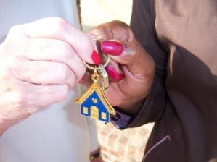
Fayetteville Area Habitat for Humanity puts God’s love into action by bringing people together to build homes, community,
and hope.

In order to be eligible for the FAHFH Homeownership Program, you must be a resident or work in Cumberland, Bladen or Sampson County and meet the following criteria.
1. DEMONSTRATE NEED:
You may qualify if your present housing meets one or more of the following:
- Substandard (recurring maintenance problems, inadequate plumbing, lack of indoor bathroom, unsafe electrical, lack of entrance and exit, leaky roof, unsafe heating or no formal heating, unsafe flooring, little or no insulation, broke or missing windows)
- Unsafe (unsafe neighborhood, heavy traffic, high crime)
- Overcrowded
- Government subsidized (public housing, tax credit, section 8)
- Unaffordable (Rent exceeds more than 30% of Household income)
- If you are homeless (no current or permanent address)
- Do not qualify for a conventional mortgage.
2. HAVE THE ABILITY TO PAY: Have a minimum gross monthly income of $1700. The ability to pay is reviewed on a case-by-case basis. It is predicted on income, expenses, current debt, and other financial obligations. You must demonstrate a consistent, stable, documented source of income; no unsatisfied liens, judgements; and the ability to pay $500-$600 a month for a mortgage payment.
- Front end Debt to Income Ratio = 30% or less
  - Monthly mortgage DIVIDED BY (/) monthly gross income
- Back end Debt to Income Ratio = 43% or less
  - All Credit reporting bills that a Household has PLUS (+) monthly mortgage payment DIVIDED BY (/) monthly gross income
- Credit is considered in the approval process

3. BE WILLING TO PARTNER: Completion of 300 hours of Sweat Equity. You must be willing to submit to a home visit and meeting with our Family Matters Committee during the application process. Approved Homebuyers complete all mandatory requirements of the Homeownership Program. An applicant cannot choose the specific location of their home and must be willing to accept a newly constructed or rehabilitated home, assigned based on availability. You must also agree to incur no new debt as a condition of acceptance into the program.
- 10 Hours of Initial Sweat Equity (Requirement as part of Application)
- Once Approved:
  - 50 Hours of Education
  - 100 On-Site Construction
  - 140 Additional Hours (Completed at Habitat Restore or other approved Non-profit Organizations)

Disqualifications
        - Failing to Report all Household Income
        - Household income exceeds 80% of Area Medium Income
        - Insufficient Income
        - Foreclosure in the last 3 years
        - Bankruptcy in the last 3 years
        - Unwillingness to partner
        - Collections/charge-offs exceeding $3,000
        - Mis-representation of any information throughout the approval process
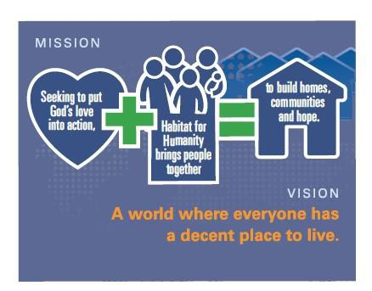
        - Outstanding balances on previous rentals
        - Inconsistent income/employment

Family Size | Annual Gross Household Income* up to
1 | $32,550
2 | $37,200
3 | $41,850
4 | $46,500
5 | $50,250
6 | $53,950
7 | $57,700
8 | $61,400
INCOME LIMITS:

If you would like to be considered for the FAHFH Homeownership Program, please complete and return
the Registration form ONLY, via mail (3833 Bragg Blvd Fayetteville, NC 28303) or email (grace@fayettevillenchabitat.org). We will then put you on schedule for homeowner orientation meeting.

Today’s Date:
REGISTRATION FORM

Which County are you applying for? Please circle one: Cumberland Sampson Bladen

Name:

Street:
Co-Applicant:

Street:

City: State: Zip: City: State: Zip:

Work Phone: ___________________________________________
Home Phone: ___________________________________________
Cell Phone: _
Email:

Is applicant a US Citizen or legal permanent resident? YES NO

Work Phone: ___________________________________________
Home Phone: ___________________________________________
Cell Phone:
Email:

Relationship to Applicant: ______________________________________
Is co- applicant a US citizen or
legal permanent resident? YES NO
Did you or anyone in your household serve or is currently serving in the military? YES NO

Is your household’s gross monthly income at least $1700 or more? ____________
(Household gross monthly income includes employment/unemployment, child support, social security, disability, etc.)
Please list all those who will be living in this home including applicant and co-applicant:

Name Gender Year of Birth

1.

2.

3.

4.
5. ______________________________________________________ __________________ ___________________________

Please describe your current living conditions:

Release: By my signature I affirm that the above information is true and correct. I understand that providing false information could cause me not to qualify to purchase a home from Fayetteville Area Habitat for Humanity.
Applicant Sign Here: ___________________________________ Co-Applicant Sign Here: _______________________________________

OFFICE USE ONLY:
Return date: _____________ Staff initials: ______________

